Title of the Paper (heading1)
1st Author (name SURNAME), email address
Research team, Name of the University

2nd Author (name SURNAME), email address
Research team, Name of the University

Abstract (heading1)
Maximum of 250 words
Please choose “Heading 1” from the style gallery above to create the heading for the abstract. Do not add page numbers. The body of the text should use the style “Normal” (see the style gallery above). The abstract should be precise but all-encompassing and should include the objectives of the study, context, theoretical standpoints, methods, instruments, results (where applicable) and conclusions.
Keywords: (max 10)

Introduction (heading 1)
The full papers should be between 10 to 20 pages. For the first level headings, choose the 'heading 1' from the style gallery. The text should use the style "normal". Please do not include page numbers or running heads.

Literature Review (heading 1)
When the direct quotation is longer than 40 words, choose the style “long quotation” from the styles gallery (see the example for a long citation below):
“Long Quotation Long Quotation Long Quotation Long Quotation Long Quotation Long Quotation Long Quotation Long Quotation Long Quotation Long Quotation Long Quotation Long Quotation Long Quotation Long Quotation Long Quotation Long Quotation Long Quotation Long Quotation Long Quotation Long Quotation Long Quotation Long Quotation Long Quotation Long Quotation Long Quotation” (Lebeaume, 2000, p.47).

Methodology (heading 1)

Context and Participants (heading 2)

Data Collection Tools

Analysis Methods

Results & Discussion
All tables and figures should be numbered and should have captions (see Figure 1 & Table 1). To create captions, use style “table/figure caption” from the style gallery. The caption of a table is placed above the table (see Table 1). However, the caption of a Figure is located under the figure (See Figure 1). Figures and Tables should be cross referred in the text.
Table 1: The table captions should appear above the table
 | L-Active Learner Involvement | L-Passive learner involvement | L-Use of L1
G1 | 10 | 47 | 10

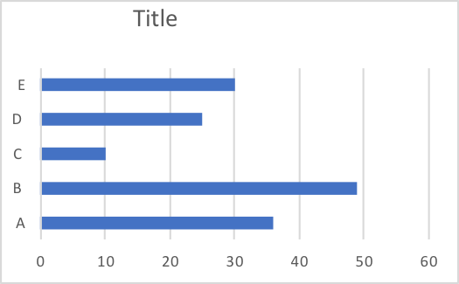
Figure 1: select the ‘figure caption’ from the quick style gallery.

Conclusion

References (heading 1)
(For citing the references use APA style. To write the references list, use the ‘references’ in style gallery above.)
Bandura, A. (1977). Social learning theory. Eglewood Cliffs, NJ: Prentice Hall.
Bruner, J. (1978). The role of dialogue in language acquisition. In A. Sinclair, R., J. Jarvelle, & W. J. M. Levelt (Eds.), The Child's Concept of Language (pp. 67-86). New York: Springer- Verlag.
Gabillon, Z., & Ailincai, R. (2016). The role of artefacts and gestures in CLIL lessons. TESOLANZ journal, Special Edition, (24), 26-37.

